NPAFC Doc.

Rev.

**Preliminary Findings of the International Year of the Salmon Pan-Pacific Winter High Seas Expedition Onboard the R/V «TINRO» during March 2-20**

by

Aleksey A. Somov1, A, Aleksander A. Starovoytov1, A, Denis N. Chulchekov1, A, Kirill K. Kivva1, B, Anton S. Khleborodov1, A, Vladimir I. Polyanichko1, A, Yuri Yu. Korolev1, A, Alina O. Bezverkhnaya1, A, Semyon V. Novokreshchennykh1, C, Valeriya A. Soshnina1, B, Ilias N. Mukhametov1, C, Valeriy F. Parkhomchuk1, A, Gennady A. Kantakov1, A,D and Evgeny A. Pakhomov2, E,F,G

Submitted to the

**NORTH PACIFIC ANADROMOUS FISH COMMISSION**

by

Russia1 and Canada2

May 2022

**THIS PAPER MAY BE CITED IN THE FOLLOWING MANNER:**

Somov, A.A., A.S. Starovoytov, D.N. Chulchekov, K.K. Kivva, A.S. Khleborodov, V.I. Polyanichko, Yu.Yu. Korolev, A.O. Bezverkhnaya, S.V. Novokreshchennykh, V.A. Soshnina, I.N. Mukhametov, V.F. Parkhomchuk, G.A. Kantakov and E.A. Pakhomov . 2022. Preliminary Findings of the International Year of the Salmon Pan-Pacific Winter High Seas Expedition Onboard the R/V «TINRO» during March 2-20. NPAFC Doc. [insert number]. [insert number of pages] pp. Russia and Canada (Available at https://npafc.org).

**Affiliations:**

A Pacific branch of Russian Federal Research Institute of Fisheries and Oceanography (VNIRO (“TINRO”)), Vladivostok, Russia

B Central office of Russian Federal Research Institute of Fisheries and Oceanography (VNIRO), Moscow, Russia

C Sakhalin branch of Russian Federal Research Institute of Fisheries and Oceanography (VNIRO (“SakhNIRO”)), Yuzhno-Sakhalinsk, Russia

D Far Eastern Ecological Center, Ltd., Yuzhno-Sakhalinsk, Russia

E Department of Earth, Ocean & Atmospheric Sciences (EOAS), 2039-2207 Main Mall, University of British Columbia, Vancouver, BC, V6T 1Z4, Canada

F Institute for the Oceans and Fisheries (IOF), AERL, 231-2202 Main Mall, University of British Columbia, Vancouver, BC, V6T 1Z4, Canada

G Hakai Institute, P.O. Box 309, Heriot Bay, BC, V0P 1H0, Canada

# Abstract

During February-March 2022, RV *TINRO* conducted the ecosystem survey south of the Aleutian Islands in the North Pacific. The expedition was an integrative part of the 2022 Pan Pacific survey of the International Year of the Salmon. The main aims of the expedition were: (i) to evaluate oceanographic dynamics in the central part of the North Pacific; (ii) to estimate composition and biomass of the pelagic zooplankton and micronekton; and (iii) to asses of the winter distribution, abundance and biomass of the Pacific salmon. In total, 32 oceanographic stations were completed covering area of ⁓530,000 km2. During the trawl survey, 27 macroplankton, micronekton and nekton species were identified including 11 fish, 7 squid, 6 jellyfish and 3 salp species. Preliminary total abundance and biomass was calculated to be 19.3 billion individuals and 429,000 tons. In terms of wet mass, biomass dominated by gelatinous macroplankton (55% of jellyfish and 25% of salps) followed by fish (16%, including 15% salmonids) and squid (4%). In total, 1146 salmon (131 chum salmon, 36 coho salmon, 942 sockeye salmon, 32 pink, 5 Chinook salmon) were caught during the trawl survey. The total standing stock of Pacific salmon in the investigated area was assessed to be ⁓ 147 million individuals or 60,800 tons. Sockeye salmon accounted for 80% of the total abundance. Preliminary acoustic data showed that while salmon was observed in the top 100 m water layer, 65% of all salmon concentrated in the top 30 m layer. The findings of this survey showed that during winter Pacific salmon are typically found in low to modest concentrations within the Subarctic Frontal system. Occasionally, subadults Pacific salmon may form locally high concentrations. Overall, the feeding intensity of Pacific salmon was not very high and gut fulness indices generally ranged from 50 to 100 ‱, indicating rather maintaining foraging feeding activity. This was confirmed by generally good fish condition factor of all species, with exception of pink salmon.

**Keywords:** Pacific salmon, North Pacific Ocean, international collaboration, winter salmon ecology, acoustic observations, salps, squid, mesopelagic fishes

# Introduction

The 2022 International Year of the Salmon Pan-Pacific Winter High Seas Expedition was an international collaborative effort between Canada, Japan, the Republic of Korea, the Russian Federation and the United States of America. The 2022 Expedition was planned to be the largest coordinated multinational survey to study salmon in the North Pacific Ocean (NPO) during the winter and builds upon previous regional expeditions: (a) the Bering-Aleutian Salmon International Survey (BASIS) (NPAFC Bull., 2009) and (b) the International Year of the Salmon (IYS) Expeditions into the Gulf of Alaska during winters of 2019 and 2020 (Pakhomov et al. 2019, Somov et al. 2020). With changing climate and associated anomalous events in the North Pacific Ocean progressively exposing salmon to conditions outside normal climate cycles, these expeditions aimed offering important insights to achieve further understanding of changing ocean conditions and their effects on salmon in the open ocean.

To date, significant resources have been invested in attempts to better understand and manage the freshwater phase of the salmon life cycle to maximize salmon productivity. Despite these research efforts, we still struggle to predict and understand inter-annual fluctuations in salmon populations. There is an urgent need in understanding the physical, chemical and biological drivers of salmon growth and survival in the open ocean to fully address current management challenges. The IYS 2019, 2020 and 2022 Expeditions have begun to accumulate novel knowledge regarding the winter-spring ocean phase of the salmon life cycle. This has offered an excellent opportunity for collaborating multilaterally with salmon-producing countries across the North Pacific to build knowledge base that can improve our ability to manage and sustain salmon populations into the future.

The 2022 Expedition was carried out between February and April of 2022 and involved five research vessels from USA, Canada and Russia and covered three zones across the North Pacific Ocean (Pakhomov et al., 2021). The overall objective of the 2022 Expedition was to demonstrate the utility of an international pan-Pacific winter ecosystem survey to understand how increasingly extreme climate variability in the North Pacific Ocean and the associated changes in the physical environment influence the abundance, distribution, migration, and growth of Pacific salmon and surrounding species The specific sub-objectives of the 2022 Expedition were as follows:

1. Determine species and stock-specific ocean distributions and relative abundances, and condition of juvenile, immature/mature Pacific salmon within the study area, and factors/mechanisms controlling them;

2. Document the spatial and temporal variation in physical and biological oceanographic conditions;

3. Document the distribution, condition, and standing stocks of zooplankton, and nekton that serve as the prey base for Pacific salmon and associated marine fishes;

4. Demonstrate the ability to effectively collaborate across the five NPAFC parties and our partners to conduct integrated ecosystem research that will support the sustainable management of salmon in a rapidly changing North Pacific Ocean.

This is a preliminary report of the results from the 2022 IYS Expedition collected onboard the R/V «TINRO». A more detailed report from each vessel will be compiled into an NPAFC Technical Report and published before the end of 2022. All participants agreed that all data collected as part of the 2022 IYS Expedition will be made publicly available.

# Materials and Methods

The key methodological approach was to conduct an international survey of salmon and the epipelagic ecosystem in the offshore regions of the NPO by deploying survey vessels at key times and areas to provide a seasonal picture of the distribution, migration and ecology of salmon and associated species in the high seas. The survey design included concurrent surveys between February–April 2022 within three zones of the North Pacific Ocean (Figure 1) and detailed in Pakhomov et al. (2021).

An ecosystem survey utilizing a trawl to capture overwintering salmon was conducted in zone 3 of the IYS 2022 Pan-Pacific Winter High Seas Expedition survey area (Figure 1) during March 2 - 20 onboard the R/V «TINRO». This vessel covered approximately 530,000 km2 of the overall survey area. This portion of the 2022 IYS Expedition was supported by the NPAFC IYS. Fourteen scientists participated onboard the R/V «TINRO», 13 from Russia and one from Canada. The science team included fish biologists, ecologists, physical and biological oceanographers, acousticians, and geneticists.

The detailed sampling protocols are outlined in Pakhomov et al. (2021). The R/V «TINRO» departed from Vladivostok, Russia with Russian scientific crew on February 5 and arrived to Dutch-Harbour (Unalaska, AK, USA) on February 26 to board the Expedition Chief Scientist Prof. Evgeny Pakhomov from Canada and load the additional equipment. Initially, it was planned to board scientist from the US and carry out sampling inside the US Exclusive Economic Zone (EEZ), however, due to unexpected political difficulties US participation was withdrawn and permission to work inside US EEZ was revoked. The second and third port call to Dutch-Harbour was also prohibited and R/V «TINRO» survey time was limited to its fuel capacity that dictated survey coverage. In total, 32 stations and 32 trawl sets were completed in zone 3 with an average distance of about 60 nm between individual stations along each meridional transect that were spaced out roughly 80 nm from each other (Figure 2). To fill the gap inside the US EEZ, IYS team and NPAFC secretariat chartered the F/V «Northwest Explorer» that completed 16 stations/trawls inside the US EEZ and 6 stations outside the US EEZ in April 2022 (Murphy et al. 2022).

The typical survey stations conducted during both daytime and nighttime consisted of:

1. CTD and Rosette casts down to 1000 m
2. Water samples:
   1. Dissolved oxygen from 0-5, 25, 50, 75, 100, 150, 200, 400, 600, 1000 m
   2. Dissolved nutrients from 0-5, 25, 50, 75, 100, 150, 200, 400, 600, 1000 m
   3. Chlorophyll-a from 0-5, 25, 50, 75, 100, 150 m
   4. eDNA from 0-5, 25, 50, 100 m
   5. Particulate organic matter (POM) from 0-5 m
   6. High-performance liquid chromatography (HPLC) pigments from 0-5 m
   7. Flow cytometry from 0-5m
   8. Fatty acids from 0-5 m
3. Plankton net(s):
   1. vertical Bongo, 0-250 m
   2. vertical Juday nets, 0-50 and 0-200 m
4. Midwater trawl towed at 4-5 knots for one hour in the top 30 meters of the water column
5. Hydroacoustic measurements throughout the full survey area
6. Observations of marine mammal and seabirds throughout the survey and during transits
7. Macroplastic photoID throughout the survey and during transits using GoPro Cameras attached to the railings
8. Microplastic stations using Neuston “Manta” net at surface towed at 2-3 knots for 15 minutes

Specific details of the protocols used are given below.

## 1. CTD Deployment, Water Sample Collection and Processing

CTD stations and water sample collections were conducted using 12-position rosette equipped with a SeaBird CTD 911 plus to a depth of 1000 m. Rosette had a capacity to carry ten 5L and two 1,8L Niskin Bottles. Bottle firing was operated remotely using Carousel Deck Unit model 33 and real-time tracking system Sea Bird Electronics model 25. Chlorophyll-a, dissolved Oxygen and dissolved nutrient samples (silicates, dissolved inorganic phosphate, nitrites, nitrates) were processed on board according to methods listed in the cruise plan (Pakhomov et al., 2021). Other water samples (eDNA, HPLC, Flow cytometry, Fatty acids) were collected according to the cruise plan (Pakhomov et al., 2021) and delivered to the laboratories of interest.

## 2. Plankton Net Deployment and Processing

The detailed protocol of Bongo and Juday net stations is presented in Pakhomov et al., 2021. In total, 32 Juday net (64 samples from 0-200 and 0-50 m at each station) and 31 Bongo net (62 samples from paired nets) were completed. Juday net samples were delivered to TINRO’s plankton lab for further analysis. Bongo net samples were transferred to the University of British Columbia.

## 3. Midwater Trawl Deployment and Processing

Trawl sets were conducted using the RT 80/396 trawl net with a 10 mm codend mesh size. Detailed trawl equipment is listed in the cruise plan (Pakhomov et al., 2021). Trawl parameters (headrope depth, vertical and horizontal openings) during each set were tracked using SIMRAD FS 70 sounder attached with conducting wire to the separate winch.

Throughout the survey, the average calculated horizontal opening ranged from 33.5 to 45.5 m (41.7 m on average); vertical opening – 24.2–32.2 m (27.2 m on average), trawling speed was 3.6–5.2 knots (4.6 kn on average); warp length – 245-283 m (255.4 on average); swept area 0.28-0.42 km2 (0.35 km2 on average); trawl mouth opening 757-1121 m2 (892 m2 on average), filtered volume 5.4-9.6*10-3 km3 (7.5*10-3 km3 on average). Technical parameters of each trawl are represented in Table 4.

Total salmon and other species abundance and biomass were calculated using the formula:

N (B) = Q *S / 1,000,000

where N, B is the number and biomass of species (units are thousand metric tonnes and million fish respectively); Q is the average distribution density of species within the survey area (individuals or kg per km2); and S is the survey area (km2). The distribution density index Q is calculated using number and weight of each individual species in the given catch (n or b), the trawl swept area (s), and the catchability coefficient of the species (k) according to the formula: q = n (b) / k * s. For more details on the applied method see two technical reports (Volvenko 1999, Volvenko 2000). Catchability coefficients for major nekton species are presented in a series of Atlases issued by the TINRO-Center (Shuntov, Bocharov et al. 2003).

From each trawl, all micronekton and nekton were processed. All salmon were identified and processed for length, weight, DNA, scales, otoliths, energy density, lipids, fatty acids and diet analysis. A subsample of the salmon catch (up to 10 individuals per trawl) was processed for fish health diagnostics. Non-salmon nekton species were identified, enumerated, measured and a subsample was frozen or preserved for subsequent laboratory analyses in Canada and Russia. Micronekton (jellyfish, mesopelagic fish, squid) were identified to the species level, measured, counted, weighed and frozen for subsequent lab analyses. In total, 3218 various samples were collected (Table 1).

## 4. Hydroacoustic Measurements

Scientific echo sounder SIMRAD EK-60 was used as a hydroacoustic measuring system with vertically directed antennas with 38 and 120 kHz frequencies, placed under the vessel's keel. The measurements were carried out in a 8-700 m layer. The upper boundary is conditioned by the depth of echo sounder antennas installation (about 5 m) and its "blind zone" (3 m at frequency 38 kHz). A multispecies echogram processing software package SALTSE (TINRO's internal developed software) was used for echograms visualization and postprocessing down to 100 m depth (Kuznetsov et al. 2021). Identification of objects recorded during the acoustic survey was based on trawl catches.

Identification of salmon echoes on echograms assumes that salmon do not generally form dense concentrations during feeding and wintering periods, and since they are fish with bladders, individual salmon should clearly appear on echograms as separate echotracks (Figure 3). It is important to select threshold values of target strength (TS) and volume backscattering force (Sv), which exclude echoes from other objects from processing. Two equations are available to calculate TS of salmonids: TS = 20log(Length) - 66 for juveniles less than 30 cm (Iida et al. 1991) and TS = 20log(Length) - 61.9 for large salmon (MacLennan, Simmonds. 1992). To calculate backscattering force, the following formula was used:

*Sv=TS-EqBeamAngle-SaCorrection*2-10*log10(SoundVelocity*PulseLen/2)-20*log10(TargetDepth-TrDepth)*

where: *PulseLen* - pulse length; *EqBeamAngle* - equivalent antenna beam opening angle; *SaCorrection* - gain correction when calculating Sv; *TrDepth* - antenna depth; *TargetDepth* - target depth.

## 5. Stomach content analysis

Salmon stomach contents were collected and analyzed onboard following an express method (Chuchukalo, Volkov 1986, Chuchukalo 2006, Volkov 2008). In short, 10–20 stomachs from each salmon size group (<30, 30-40, 40-50, >50 cm) were collected and the fullness of each stomach was estimated (from 0 – empty to 4 – very full). The stomach contents were weighed and identified to the lowest taxonomic level possible and the digestion state was estimated visually (from 1 - fresh food to 4 - completely digested). Diet composition was visually estimated, and nekton and planktonic components were weighted separately. The index of stomach fullness (ISF) was calculated as weight of the stomach contents divided by fish weight and multiplied by 10,000 (Volkov 2008). To ensure the accuracy of the onboard analysis, individual stomach contents were frozen and kept for laboratory confirmation at UBC. To calculate condition factor (CF) we used Fulton’s formula: CF=W*100000/FL3, where W - weight, g, FL - full length, cm.

## 7. Sample Data Entry and Organization

All data collected in this expedition will be publicly available on the shortest feasible timescale through the Tula Foundation and Hakai Institute (NPAFC Doc. 1913 Rev. 3 2020) with arrangements within the Global Ocean Observing System (GOOS) which will be identified as IYS-GOOS.

# Preliminary Findings

## Weather conditions

The study area in March 2022 was under the high gradient zone between the centers of the Aleutian Minimum and the Pacific Maximum. Active cyclogenesis was observed in the northwestern part of the Pacific Ocean during the entire survey. A high-gradient baric formation was observed over the study area during the survey. Numerous deep marine and continental young cyclones of southern and southeastern origin passed through the surveyed region accompanied with stormy weather conditions. As a result, about 76 hours of work time were lost to the stormy weather.

## Oceanography and chemistry

The current velocity was 4-5 cm/s within most of the study area. In the zone of water mixing it was slightly higher (up to 7 cm/s), and the maximum values (10 cm/s) were observed in the vicinity of the anticyclonic eddy located in the northeastern part of the study area (Figure 4). The geostrophic component of the current in the studied area averaged 2.3 cm/s with a northeastern direction.

The majority of study area was occupied by the subarctic waters and the waters of the subarctic frontal zone. The adjacent transformed subtropical waters were observed in the southwestern part of the survey (Figure 5). The distribution of surface temperature and salinity (Figure 5) was predominantly zonal and was in accordance with the water mass structure. Isolines of thermohaline characteristics were elongated in the eastern and northeastern direction. During the study period, water temperature in the surface layer varied from 4.5 to 8.2 °C, salinity varied from 32.45 to 33.39 psu. The main feature characteristic of the water column was the presence of a solid isothermal (mixed) layer (ML), the average depth of which reached 100 m (Figure 5). The main differences among the distinguished types of water column structure consisted in the characteristics of the subsurface layers, namely the presence or absence of cold and warm intermediate layers (CIL and WIL) and their configuration (Figure 6).

The distribution of dissolved oxygen in the surface layer in winter and early spring in subarctic is usually controlled by the distribution of oxygen solubility, while the low rate of photosynthesis (the highest chlorophyll concentration never exceeded 0.6 mg.m-3) did not lead to significant oxygen oversaturation. Therefore, during the period of the survey dissolved oxygen concentration mostly depended on temperature and water salinity. There was an increase in dissolved oxygen concentration in the ML from 6.8-6.9 ml/l in the southwestern part occupied by warmer and saltier waters to about 7.4 ml/l in northeastern part (Figure 7). The direct relation of dissolved oxygen concentration to its solubility is demonstrated by the values of relative oxygen saturation of water being in the range of 100-102 % everywhere in the ML within the study area (Figure 7). Only along the easternmost section the value of this parameter increased up to 104 %. Interestingly, the highest oxygen saturation of water within the ML was often observed not at the surface, but at depth of 25, 50 or 75 m (not shown in the figures). Although oxygen oversaturation did not exceed 5 % of the solubility value (water oxygen saturation of 105 %, oxygen excess of about 0.5 ml/l), this allows us to conclude that active spring phytoplankton development was at initial stages.

The distribution of hydrochemical parameters horizontally and vertically (Figure 8) generally corresponded to the distribution of thermohaline characteristics of waters. In general, the distribution of hydrochemical parameters had a zonal character. In the northeastern part of the study area, the vertical distribution of parameters was influenced by a mesoscale anticyclonic eddy (Figure 8).

## Pacific salmon

In trawl catches, Pacific salmon were represented by all species except for cherry salmon which inhabits only the westernmost part of the North Pacific. No steelhead (which taxonomy status is debatable) was caught as well. All salmon caught were immature. Both sockeye and chum salmon were represented by first marine year juveniles and older individuals. Chinook salmon were represented only by individuals older than first marine year. In total, 1146 salmon (131 chum salmon, 36 coho salmon, 942 sockeye salmon, 32 pink, 5 Chinook salmon) were caught during the trawl survey.

**Sockeye salmon**were the most abundant species caught in the study area in March 2022 and occurred in 25 catches. The most of positive catches of age .1+ sockeye varied within 1-15 ind.hour-1, however, 581 individuals of age .1+ sockeye were caught in trawl №13 (Figure 9), which was the highest catch of this species during the Pan-Pacific survey and (in combination with age .2+ sockeye and other salmon species) this was the highest salmon trawl catch among all winter-spring trawl surveys ever conducted.

The presence of an extra-high catch of .1+ age sockeye in accordance with acoustic observations indicates that juveniles might have formed dense local aggregations during the winter-spring period. Perhaps, such aggregations are short-lived since the repeate sampling at the same station by the F/V "Northwest explorer" caught only 10 sockeye (Murphy et al.2022).

Based on the spatial distribution of the .1+ age sockeye catches (Figure 9), their main aggregations inhabited the northeastern part of the study area. The majority of the .1+ age catches were observed at temperatures of 5 to 6 oC, with three occurrences at temperatures of 6.5 to 7 oC.

The catch distribution of age .2+ sockeye was more uniform within the study area (Figure 9). The positive catches ranged from 1 to 68 fish/hour, with an average of 13 fish/hour at temperatures of 5 to 8 oC. No sockeye were observed in the southwestern part of the study area, which was influenced by subtropical waters and where salps occurred in high concentrations.

Sockeye varied in size from 22 to 58 cm (Figure 10). Apparently, the majority of individuals caught (99%) belonged to two age groups: .1+ (22-33 cm) and .2+ (35-47 cm), with only a few individuals of age .3+. No significant differences in average size and weight between females and males of sockeye were noted, with the exception of age .2+ length (Table 2). Condition factor of sockeye ranged from 0.8 to 1.2 in both size groups with the most frequent values varying between 0.95 and 1.05 (Figure 11).

Stomach analysis showed that sockeye consumed mostly amphipods, euphausiids, oikopleurans and fishes in comparably equal proportions (Figure 12). The proportion of fish and squid in the diet increased with size. Averaged ISF for .1+ sockeye was 94 ‱, while for .2+ sockeye – 36 ‱.

**Chum salmon**were the second most abundant Pacific salmon species counted in the study area in March 2022 and occurred in 16 trawls. Chum was represented in three size-age groups: 0.1+ - 22 to 28 cm, 0.2+ - 33 to 44 cm, 0.3+ and older - 45 to 58 cm (Figure 10). Positive catches of chum aged 0.1+ mostly varied within 1-4 ind.hour-1 with a single catch of 27 individuals in trawl № 26 (Figure 9). Chum aged 0.2+ and older occurred in the amount of 1-32 ind.hour-1 with the majority of values being in range of 1-4 ind.hour-1 (Figure 10).

The spatial distribution of average chum salmon length was characterized by the dominance of larger-sized fish on the northern (near the US EEZ border) and southern periphery of the study area, while smaller fish were prevailing in its western periphery. Chum were observed at water temperatures of 5-8 °C, and their maximum average catches were recorded at water temperatures of 5.5-6.5°C (Figure 9). No significant differences in average size and weight between females and males of chum were noted, with the exception of age .2+ weight (Table 2). Condition factor of chum ranged from 0.8 to 1.15 in both size groups with the most frequent values between 0.9 and 1.05 (Figure 11).

Chum aged 0.1+ consumed mostly oikopleurans with a significant share of amphipods (Figure 12), older fishes fed on small jellyfishes and ctenophores, oikopleurans, euphausiids and amphipods in almost equal proportions (Figure 12). Averaged ISF for 0.1+ chum was 129 ‱, while older chum – 56 ‱.

**Coho salmon**were represented in 17 catches with abundance in range of 1-5 ind.hour-1. No hotspots of its abundance were observed in the study area, thus its spatial distribution seems to be uniform. However, positive catches predominantly were observed in the western part of the study area at temperatures of 6-8 °C (Figure 9). Coho varied in size from 21.4 to 41 cm (Figure 10). No significant differences in average size and weight between females and males of coho were noted (Table 2). Condition factor of coho ranged from 0.8 to 1.15 with the most frequent values between 1 and 1.1 (Figure 11).

Stomach content of coho mostly consisted of squids with significant portion of pteropods and amphipods (Figure 12). Averaged ISF of coho was 80 ‱.

**Pink salmon**were represented in 10 trawls. The abundance of pink salmon in those trawls was in range of 1-2 ind.hour-1, while in two trawls there 11 and 12 pink salmon individuals were caught. There was no clear pattern of its spatial distribution within study area (Figure 9). Pink salmon occurred at temperatures of 4.6-6.5 °C (Figure 9). Pink varied in size from 23.9 to 34 cm (Figure 10). No significant differences in average size and weight between females and males of pink salmon were noted (Table 2). Condition factor of pink salmon ranged from 0.65 to 1.0 with the most frequent value of 0.85 (Figure 11). In comparison to other species, CF of pink was the lowest.

The majority of pink salmon diet included amphipods, pteropods and euphausiids (Figure 12). Averaged ISF for pink was 81 ‱.

**Chinook salmon**occurred in only 4 trawls with densities of 1-2 ind.hour-1 (Figure 9). Size of chinook salmon varied between 44.5 to 48.8 cm (Figure 10). Condition factor of all chinook caught was higher than 1.0 (Figure 11). The majority stomach content consisted of squids (Figure 12). Averaged ISF for Chinook was – 44 ‱.

The total estimated abundance and biomass of Pacific salmon in the 0-30 m layer within the study area estimated based on the trawl survey was 146.8 million ind. and 60.8 thousand metric tonnes, respectively (Table 3). It is known that surface isothermal ML, which is believed to be the layer of Pacific salmon habitat, reaches 100 m depth in winter-spring in the studied area. Previous studies in the NPO have shown that in winter-spring salmon are distributed not only in the upper 0-30 m layer, but also at deeper depths (Starovoytov et al. 2009, Naydenko et al. 2010, Glebov et al. 2011). For example, in the 30-60 m layer their concentrations were comparable and, sometimes, even higher, than in the layer 0-30 m.

According to acoustic surveys in March 2-20, 2022, the ratio of salmonids in the 0-30 m to 30-100 m layer was 65/35% (Figure 13). This observation allows us to estimate total salmon abundance and biomass in the 0-100 m layer of about 225.8 million and 93.5 thousand tons, respectively.

Further DNA analysis will make it possible to determine the population identity of mixed catches of Pacific salmon. However, we assume that most of the sockeye salmon accounted in the study area belonged to Bristol Bay population. Pink salmon could have originated from either the Alaskan populations or the eastern Kamchatka populations. The results of the survey preliminarily confirm the low level of Eastern Kamchatka pink salmon abundance generation of 2020, as well as the quite high level of the Bristol Bay sockeye salmon abundance.

The Pacific salmon trawl and acoustic distribution suggest that during the winter-spring period Pacific salmon were very dispersed within the study area with no obvious patterns in relation to temperature or longitude in the subarctic frontal zone. However, despite generally dispersed distribution, there was evidence that juvenile Pacific salmon can form short-term localized dense aggregations. The joint analysis of catch data from Pan-Pacific expedition in accordance with salmon population status might reveal some patterns in salmon spatial and thermal distribution.

In March 2022, the range of vertical migrations of salmon according to acoustic data was wider (down to 100 m) compared to the summer period (usually does not exceed 50 m depth), due to the increase in thickness of the upper ML.

Stomach content analysis showed that feeding intensity of the majority of individuals was low: about 90% of all analyzed stomachs had a score of fulness-1, although some individuals had full stomachs. Stomach fullness indices (ISF) of Pacific salmon were, on average, at 50-100 ‱. We assume this index was not critical for salmon survival, but rather indicated a feeding regime sufficient to support winter survival. Normal biological condition of salmon is also evidenced by the condition factor, which was close to 1.0 in most cases (except for pink salmon).

## Other species

A total of 27 species (including Pacific salmon) of nekton and macroplankton (Table 3) were observed in catches during the R/V «TINRO» survey in March 2-20, 2022, including 11 species of fish, 7 species of squid, 6 species of jellyfish, and 3 species of salps.

The most frequently encountered species were: *Tarletonbeania crenularis (tailory)* - 80% (only night trawls accounted), sockeye salmon (*O. nerka*) - 78%, *Aequorea* sp. - 72%, *Phacellophora catschatica* - 72%, *Boreoteuthis borealis* - 67% (only night trawls accounted). The most abundant species were salps *Salpa aspera*, squid *Okutania anonycha* , *Gasterosteus aculeatus*, and jellyfish *Chrysaora melonaster*, *Phacellophora camtshchatica* (Table 3).

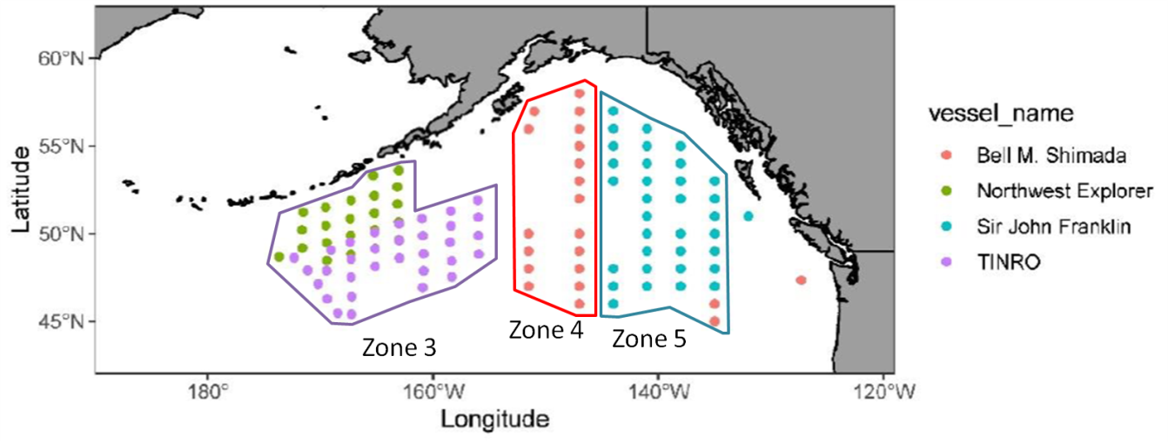

Figure 1. Expedition trawl stations and zones sampled during the IYS 2022 Pan-Pacific Winter High Seas Expedition.

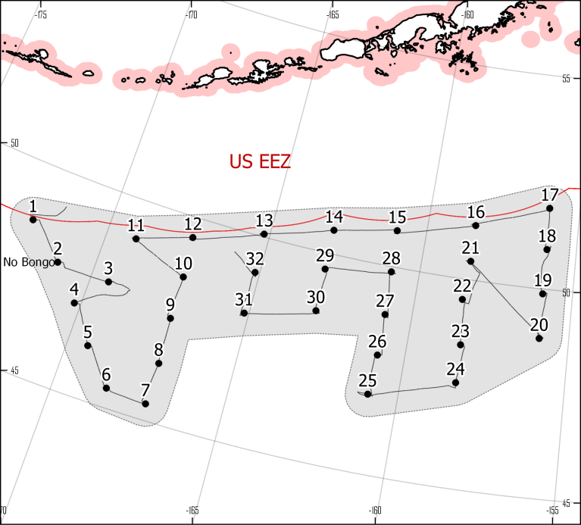

Figure 2. Stations completed during R/V «TINRO» cruise during March 2-20

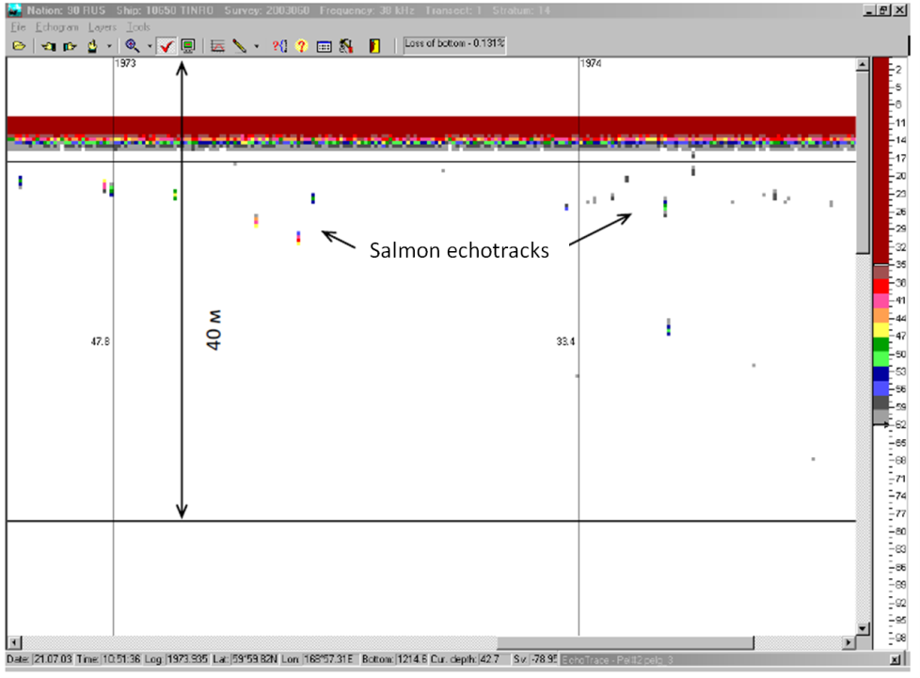

Figure 3. Fragment of the acoustic salmon echotracks in the BiView program window (included in the SALTSE package)

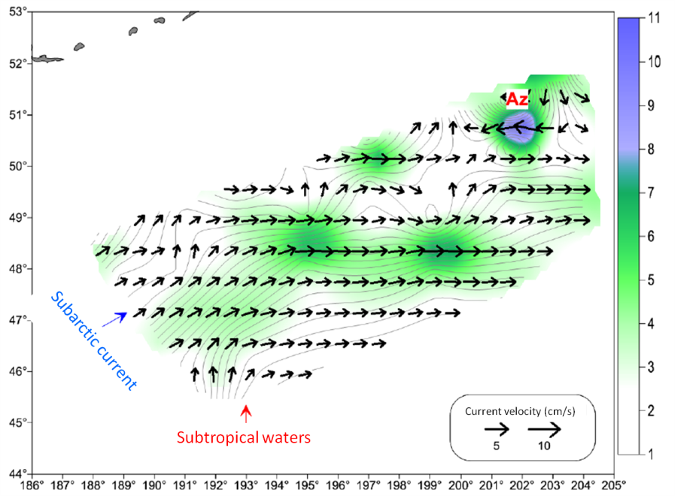

Figure 4. Dynamic topography at 0 dbar relative to 1000 dbar (shading) and corresponding surface geostrophic current (vectors).

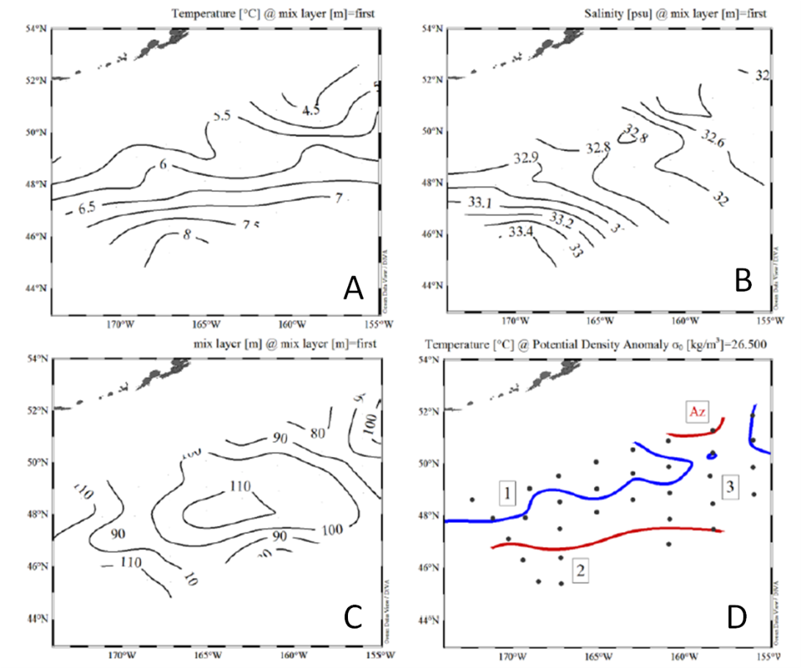

Figure 5. Spatial distribution of temperature (A), salinity (B) in the upper quasi-homogeneous mixed layer (ML), ML topography (C), conditional boundaries of different water column structure types (D). Numbers indication: 1 - subarctic waters, 2 - subtropical waters, 3 - frontal zone, AZ - anticyclonic mesoscale eddy.

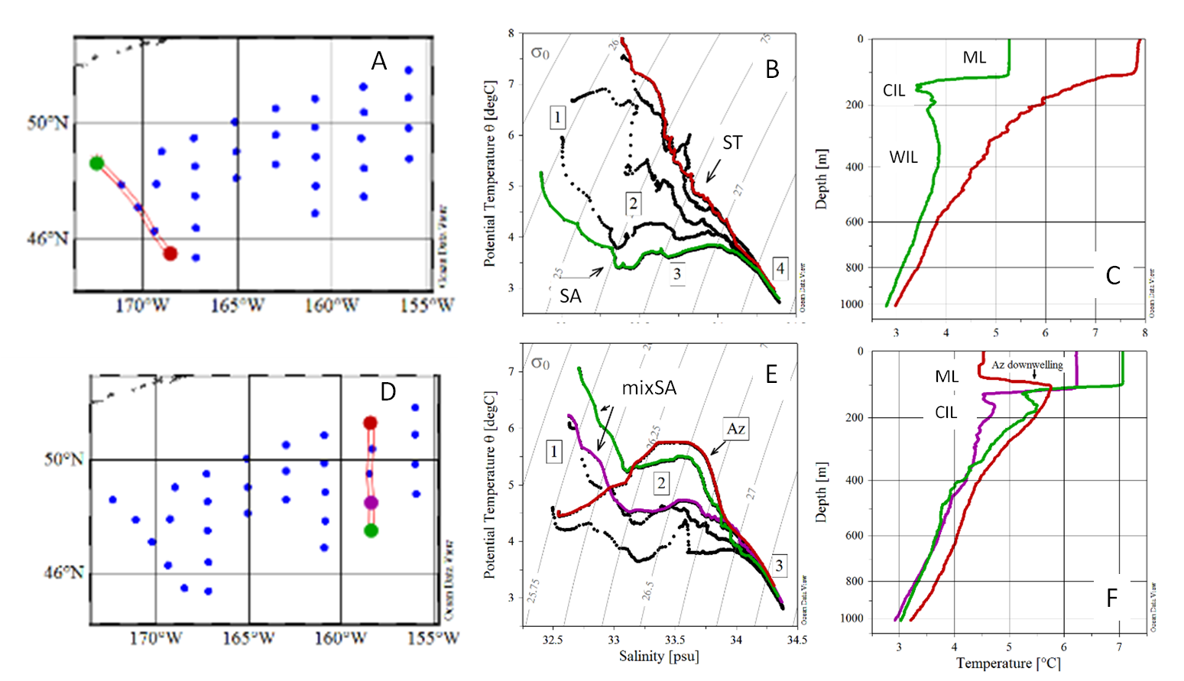

Figure 6. T,S-diagram (B, E) and vertical temperature profiles (C, F), at the western (A) and eastern (D) transects. ST – subtropical water column structure, SA – subarctic water column structure, mixSA – mixed type of water structure, AZ - anticyclonic mesoscale eddy, CIL – cold intermediate layer, WIL – warm intermediate level. Numbers indication: 1 – upper mixed layer (ML), 2 - CIL, 3 - WIL, 4 – deep waters

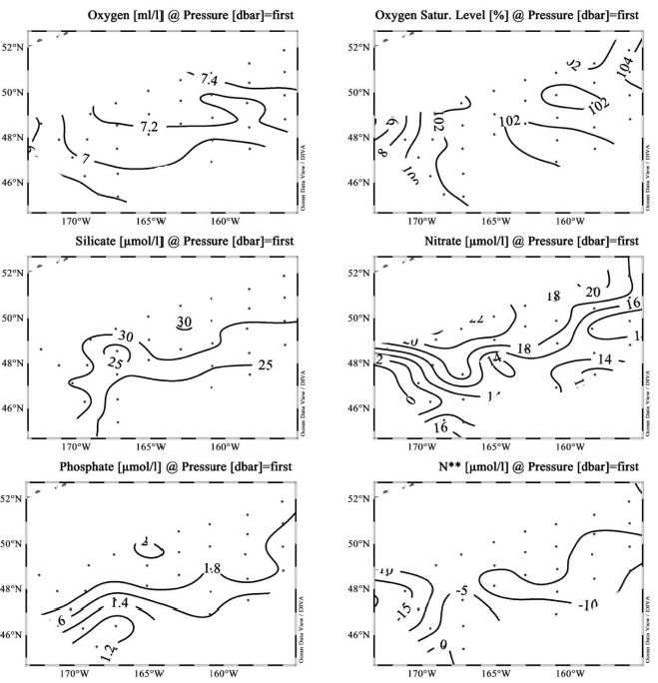

Figure 7. Distribution of hydrochemical parameters at the ocean surface. Dissolved oxygen concentration (ml/l, top left), relative water oxygen saturation (%, top right), silicate concentration (µg-at/l, center left), nitrate (µg-at/l, center right), phosphate (µg-at/l, bottom left), and parameter N** (µg-at/l, bottom right).

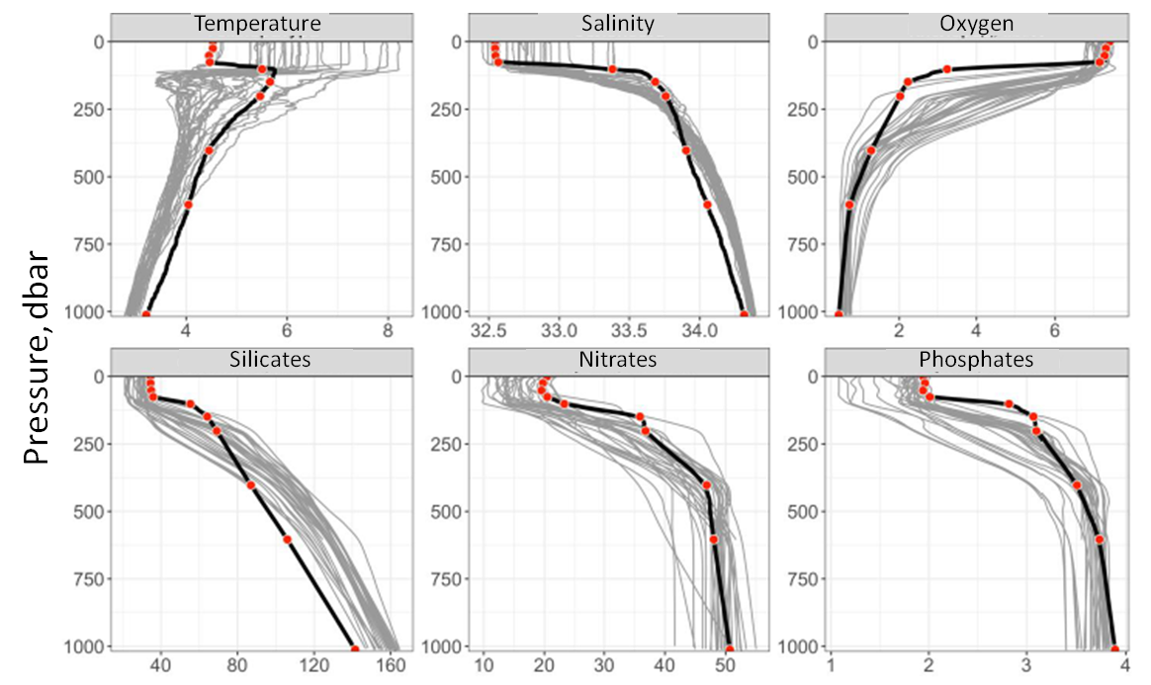

Figure 8. Vertical distribution of physical and hydrochemical parameters. Temperature (oC, top left), salinity (psu, top center), dissolved oxygen concentration (ml/l, top right), mineral dissolved silicon, nitrate nitrogen and phosphorus (µg-at/l, bottom left, center and right respectively). Gray lines - distribution of measured (temperature and salinity) or interpolated (chemical constituents) parameter values at all stations of the polygon; bold black lines - distribution of interpolated parameter values at the station 16 (Anticyclonic eddy); red points - sampling horizons and measured parameter values

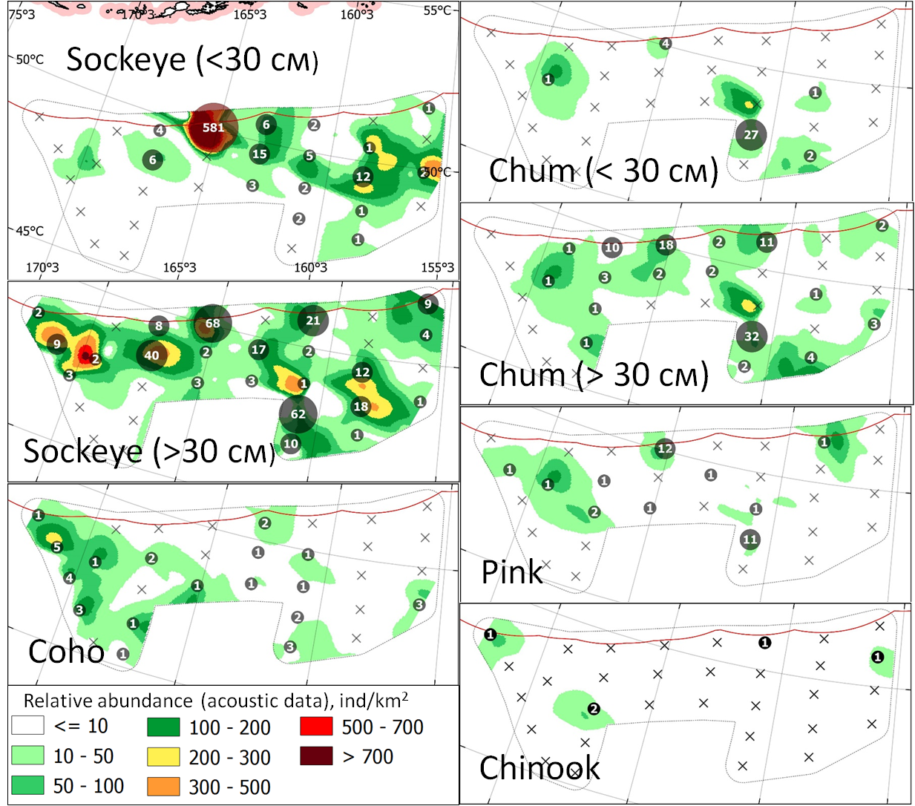

Figure 9. Pacific salmon distribution within the R/V «TINRO» study area. Circles indicate trawl catches; color fill indicates acoustic backscatter density of salmon

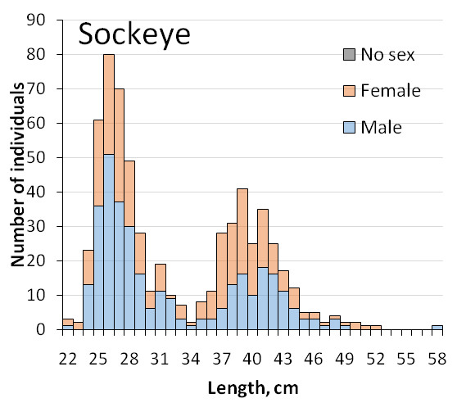 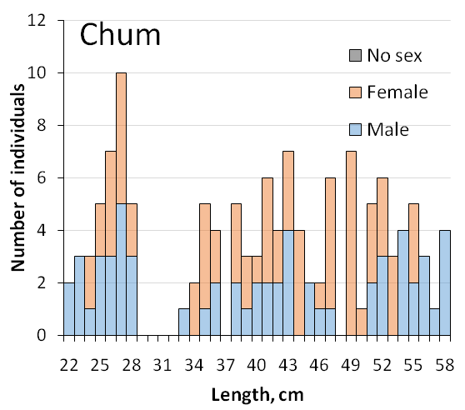 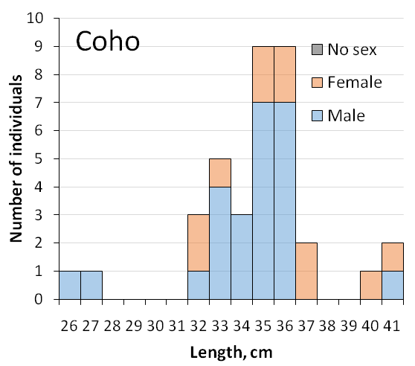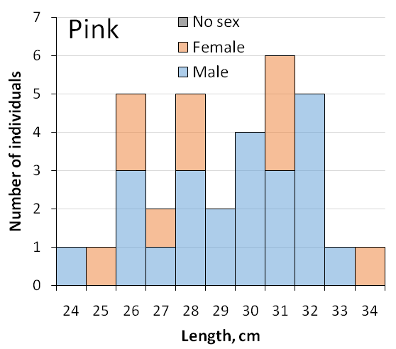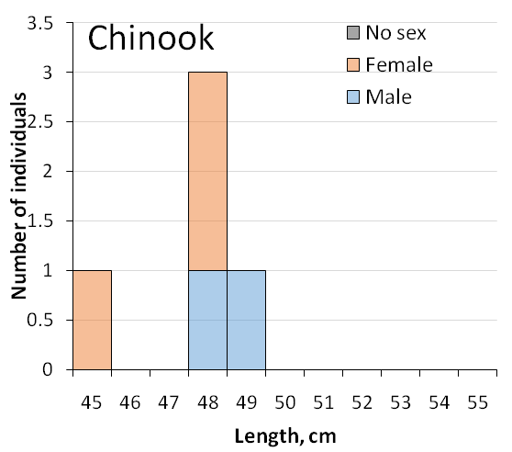

Figure 10. Length frequency of Pacific salmon within the R/V «TINRO» study area,  
March 2-20, 2022

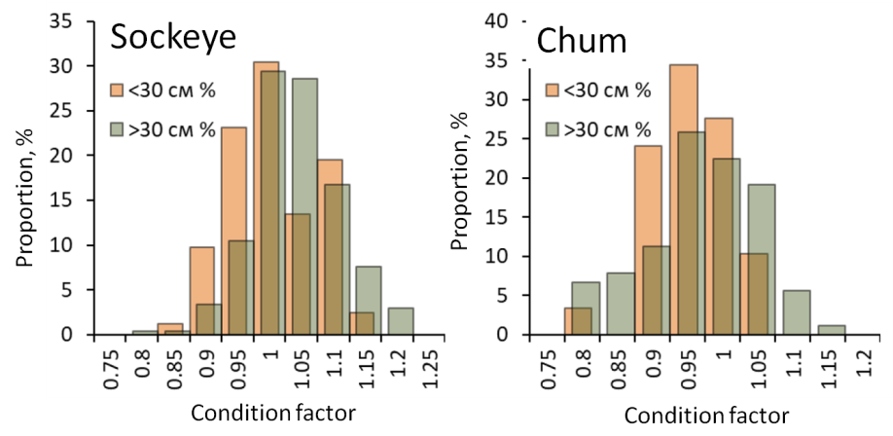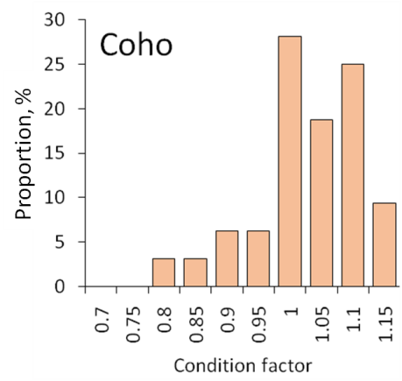 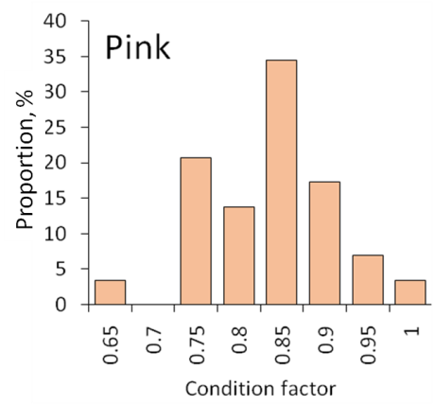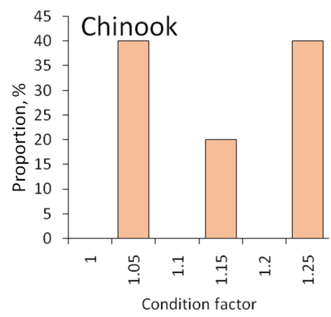

Figure 11. Condition factor frequency of Pacific salmon within the R/V «TINRO» study area,  
March 2-20, 2022

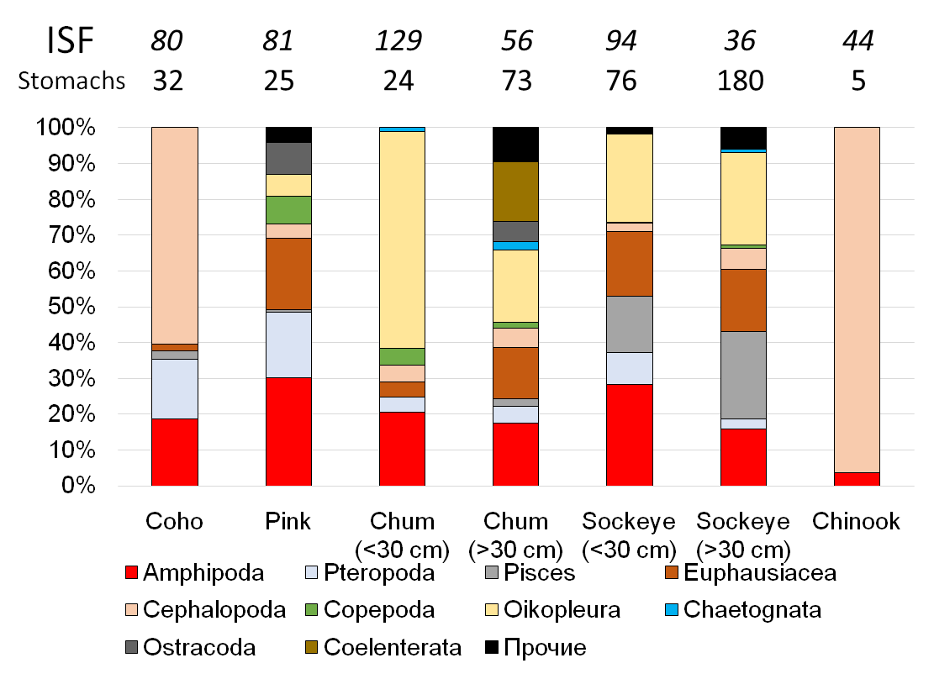

Figure 12. Preliminary results of onboard diet analysis of Pacific salmon species within the R/V «TINRO» study area, March 2-20, 2022

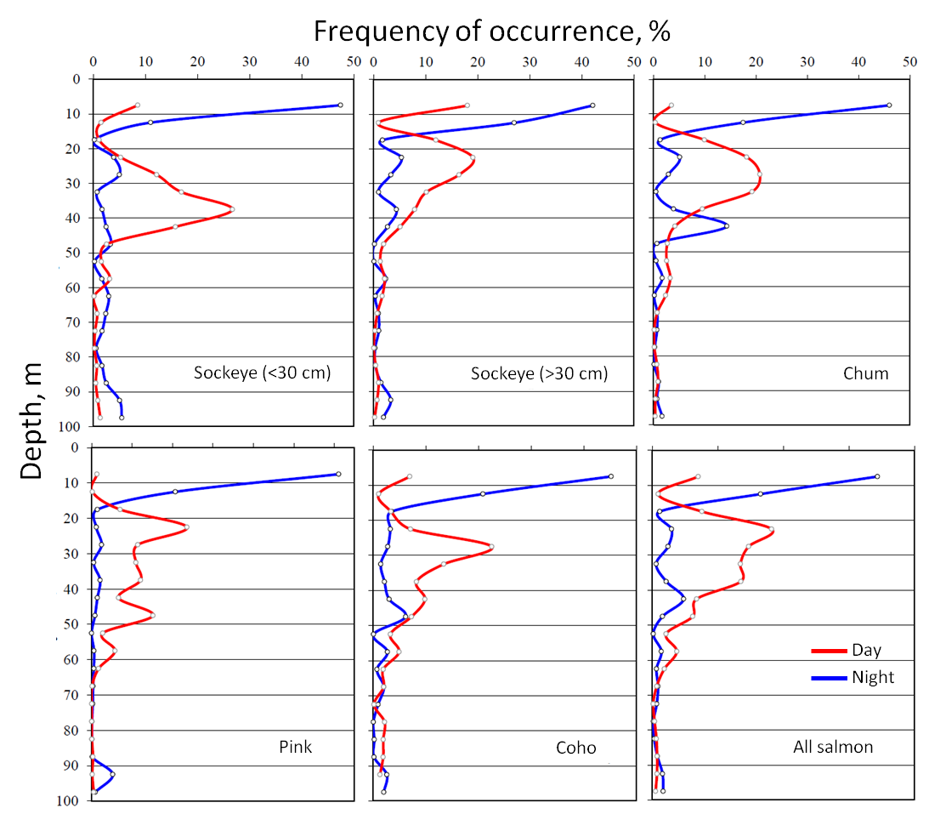

Figure 13. Vertical distribution of pacific salmon according to acoustic data

Table 1. Quantity and quality of sample collected during R/V «TINRO» cruise

|  |  |  |  |  |  |  |  |  |
| --- | --- | --- | --- | --- | --- | --- | --- | --- |
| **Species\Sample** | **Gills** | **Scale** | **DNA** | **Head** | **Gonads** | **Liver** | **Muscle** | **Total** |
| **Pink** | 22 | 28 | 29 | 29 | 13 | 29 | 58 | **208** |
| **Chum** | 52 | 116 | 118 | 98 | 57 | 97 | 196 | **734** |
| **Coho** | 32 | 31 | 32 | 32 | 8 | 32 | 64 | **231** |
| **Sockeye** | 126 | 320 | 320 | 278 | 130 | 276 | 556 | **2006** |
| **Chinook** | 5 | 5 | 5 | 5 | 4 | 5 | 10 | **39** |
| **Total** | **237** | **500** | **504** | **442** | **212** | **439** | **884** | **3218** |

Table 2. Average values of length and weight of Pacific salmon caught in the R/V «TINRO» cruise, March 2-20, 2022

|  |  |  |  |  |  |  |  |  |  |
| --- | --- | --- | --- | --- | --- | --- | --- | --- | --- |
| Specie | Sex | Length, cm | |  | Weight, g | | N | p-value | |
| Avg | SD |  | Avg | SD | Length | Weight |
| Pink | ♂ | 29.1 | 2.5 |  | 212 | 52 | 19 | 0.5334 | 0.9959 |
| ♀ | 28.4 | 2.8 |  | 212 | 74 | 10 |
| Coho | ♂ | 33.9 | 3.0 |  | 419 | 112 | 25 | 0.2337 | 0.2516 |
| ♀ | 35.5 | 2.9 |  | 495 | 152 | 7 |
| Chum (0.1+) | ♂ | 25.3 | 2.1 |  | 162 | 42 | 16 | 0.7387 | 0.8285 |
| ♀ | 25.5 | 1.3 |  | 165 | 28 | 13 |
| Chum (0.2+) | ♂ | 47.0 | 7.7 |  | 1129 | 559 | 38 | 0.06152 | **0.03849** |
| ♀ | 44.1 | 6.2 |  | 906 | 385 | 51 |
| Sockeye (.1+) | ♂ | 27.8 | 2.4 |  | 225 | 60 | 58 | 0.5262 | 0.5615 |
| ♀ | 27.5 | 2.4 |  | 218 | 59 | 48 |
| Sockeye (.2+) | ♂ | 40.6 | 3.6 |  | 736 | 240 | 100 | **0.03454** | 0.0592 |
| ♀ | 39.5 | 3.5 |  | 676 | 222 | 114 |
| Chinook | ♂ | 48.1 | 1.1 |  | 1419 | 106 | 2 | NA | NA |
| ♀ | 46.6 | 1.8 |  | 1132 | 192 | 3 |

Table 3. Species composition of trawl catches and abundance estimations

|  |  |  |  |  |  |  |  |
| --- | --- | --- | --- | --- | --- | --- | --- |
| **№** | **Family, species** | **k** | **Caught number** | **Caught weight, kg** | **Total abundance, million individuals** | **Total biomass, metric tonnes** | **Occurrence, %** |
|
|  | **Lamnidae** |  |  |  |  |  |  |
| *1* | *Lamna ditropis* | *0.5* | 1 | 65 | 0.1 | 5.5 | 3.1 |
|  | **Salmonidae** |  |  |  |  |  |  |
| *2* | *Oncorhynchus gorbuscha (>30 см)* | *0.3* | 13 | 3.38 | 2 | 0.51 | 31.25 |
|  | *Oncorhynchus gorbuscha (<30 см)* | *0.4* | 19 | 3.34 | 2.1 | 0.38 |
| *3* | *Oncorhynchus keta (<30 см)* | *0.4* | 35 | 5.7 | 3.9 | 0.63 | 15.63 |
|  | *Oncorhynchus keta (>30 см)* | *0.3* | 96 | 95.37 | 14.4 | 14.6 | 59.4 |
| *4* | *Oncorhynchus kisutch* | *0.3* | 36 | 16.015 | 5.7 | 2.6 | 53.1 |
| *5* | *Oncorhynchus nerka (>30 см)* | *0.3* | 298 | 183.713 | 45.3 | 28.1 | 68.8 |
|  | *Oncorhynchus nerka (<30 см)* | *0.4* | 644 | 116.161 | 72.7 | 13.1 | 50 |
| *6* | *Oncorhynchus tschawytscha* | *0.3* | 5 | 6.235 | 0.8 | 0.9 | 12.5 |
|  | **Myctophidae** |  |  |  |  |  |  |
| *7* | *Diaphus theta\** | *0.1* | 8 | 0.014 | 9.4 | 0.02 | 13.33 |
| *8* | *Stenobrachius leucopsarus\** | *0.1* | 12 | 0.028 | 12.1 | 0.03 | 13.33 |
| *9* | *Tarletonbeania crenularis\** | *0.1* | 313 | 0.572 | 316 | 0.6 | 80 |
|  | **Gasterosteidae** |  |  |  |  |  |  |
| *10* | *Gasterosteus aculeatus* | *0.05* | 351 | 1.738 | 317.8 | 1.6 |  |
|  | **Zaproridae** |  |  |  |  |  |  |
| *11* | *Zaprora silenus* | *0.5* | 1 | 0.092 | 0.1 | 0.01 |  |
|  | **All fishes** |  | **1832** | **497.358** | **802.1** | **68.5** |  |
|  | **Onychoteuthidae** |  |  |  |  |  |  |
| *12* | *Onychoteuthis borealijaponica\** | *0.1* | 22 | 3.973 | 21.5 | 4 | 66.7 |
|  | **Gonatidae** |  |  |  |  |  |  |
| *13* | *Boreoteuthis borealis\** | *0.1* | 78 | 2.663 | 80.1 | 2.7 | 66.7 |
|  | *Boreoteuthis borealis (juv.)\** | *0.01* | 4 | 0.01 | 43.7 | 0.11 | 20 |
| *14* | *Gonatidae sp. (juv.)* | *0.01* | 10 | 0.024 | 47.2 | 0.11 |  |
| *15* | *Gonatus kamtschaticus* | *0.1* | 6 | 0.292 | 2.8 | 0.14 |  |
| *16* | *Gonatus madokai* | *0.1* | NA | 0.12 |  | 0.06 |  |
| *17* | *Okutania anonycha\** | *0.1* | 2031 | 9.682 | 2002.3 | 9.6 | 33.3 |
|  | **Chiroteuthidae** |  |  |  |  |  |  |
| *18* | *Chiroteuthis calyx* | *0.1* | 2 | 0.065 | 2.4 | 0.08 | 3.13 |
|  | **All cephalopods** |  | **2153** | **16.829** | **2199.9** | **16.8** |  |
|  | **All nektonic species** |  | **3985** | **514.187** | **3002.1** | **85.3** |  |
|  | ***Jellyfishes*** |  |  |  |  |  |  |
| *19* | *Aequorea sp.* | *0.1* | NA | 86.13 | 59.7 | 41.8 | 71.9 |
| *20-22* | *Aurelia* spp. | *0.1* | 18 | 3.75 | 8.4 | 1.74 | 34.38 |
| *23* | *Chrysaora melonaster* | *0.1* | 509 | 120.982 | 249.9 | 60.1 | 31.3 |
| *24* | *Phacellophora camtshchatica* | *0.1* | 469 | 275.657 | 222.6 | 130.9 | 71.9 |
|  | **All jellyfishes** |  | **996** | **486.519** | **540.6** | **234.5** |  |
|  | ***Salps*** |  |  |  |  |  |  |
| *25* | *Aethopropra sp.* | *0.5* | NA | 8.036 |  | 0.8 | 6.3 |
| *26* | *Salpa aspera* | *0.05* | 14468 | 96.013 | 15762.6 | 104.4 | 12.5 |
| *27* | *Salpa maxima* | *0.05* | NA | 4.14 |  | 4.1 | 3.1 |
|  | **Total** |  | **19449** | **1108.895** | **19305.3** | **429.1** |  |

*Abundance and biomass estimations based on night trawls, k – catchability coefficient

Table 4. Technical parameters of trawls and Pacific salmon catches

|  |  |  |  |  |  |  |  |  |  |  |  |  |  |  |  |  |  |  |  |
| --- | --- | --- | --- | --- | --- | --- | --- | --- | --- | --- | --- | --- | --- | --- | --- | --- | --- | --- | --- |
| № | X | Y | Date/time (UTC) | D | V | Course | H | T0 | Wind | Waves | VO | HO | WR | Night/day | pink | chum | sockeye | Chinook | coho |
| 1 | -172.32 | 48.63 | 02.03.2022 4:10 | 1 | 5 | 71 | 0 | 5.2 | 250/14 | 3 | 24.2 | 42.3 | 254.2 | Day | 0 | 0 | 2 | 1 | 1 |
| 2 | -171.11 | 47.91 | 02.03.2022 14:58 | 1 | 4.5 | 69 | 0 | 5.9 | 250/18 | 4 | 27.2 | 43.5 | 249.2 | Night | 1 | 0 | 9 | 0 | 5 |
| 3 | -169.43 | 47.89 | 03.03.2022 1:23 | 1 | 4.8 | 63 | 0 | 5.9 | 250/10 | 4 | 28.7 | 39.3 | 245 | Day | 1 | 2 | 2 | 0 | 1 |
| 4 | -170.2 | 47.14 | 04.03.2022 6:23 | 1 | 4.7 | 77 | 0 | 6.7 | 290/12 | 3 | 28.8 | 33.5 | 250 | Night | 0 | 0 | 3 | 0 | 4 |
| 5 | -169.39 | 46.29 | 04.03.2022 16:30 | 1 | 4.2 | 80 | 0 | 7.5 | 285/14 | 3 | 25.2 | 43.5 | 254.2 | Night | 0 | 0 | 0 | 0 | 1 |
| 6 | -168.46 | 45.47 | 05.03.2022 1:57 | 1 | 5.2 | 106 | 0 | 7.9 | ind. | 3 | 29.3 | 40.8 | 250 | Day | 0 | 0 | 0 | 0 | 0 |
| 7 | -167.23 | 45.4 | 05.03.2022 10:19 | 1 | 4.9 | 289 | 0 | 8.2 | 110/10 | 2 | 28.3 | 35.3 | 250 | Night | 0 | 0 | 0 | 0 | 1 |
| 8 | -167.21 | 46.42 | 05.03.2022 18:44 | 1 | 3.6 | 340 | 0 | 7.8 | 142/11 | 1.5 | 24.2 | 42.5 | 250 | Day | 0 | 1 | 0 | 0 | 1 |
| 9 | -167.28 | 47.53 | 06.03.2022 4:36 | 1 | 4.7 | 304 | 0 | 6.4 | 125/14 | 2 | 27 | 41.7 | 250 | Night | 2 | 1 | 0 | 2 | 0 |
| 10 | -167.28 | 48.56 | 06.03.2022 13:30 | 1 | 4.7 | 285 | 0 | 6.1 | 110/12 | 2.5 | 27 | 43.3 | 250 | Night | 1 | 3 | 46 | 0 | 2 |
| 11 | -169.07 | 49.07 | 06.03.2022 23:40 | 1 | 4.3 | 264 | 0 | 5.7 | 55/13 | 2 | 26.2 | 42 | 266.7 | Day | 0 | 1 | 0 | 0 | 0 |
| 12 | -167.36 | 49.52 | 07.03.2022 12:29 | 1 | 4.2 | 216 | 0 | 5.4 | 354/11 | 3 | 29.3 | 44.2 | 250 | Night | 0 | 10 | 12 | 0 | 0 |
| 13 | -165.19 | 50.07 | 08.03.2022 3:12 | 1 | 4.7 | 254 | 0 | 5.6 | ind. | 3 | 28.2 | 42.3 | 250 | Day | 12 | 22 | 649 | 0 | 0 |
| 14 | -163.01 | 50.56 | 08.03.2022 16:21 | 1 | 3.9 | 78 | 0 | 5.5 | 83/8 | 2.5 | 32.3 | 44.2 | 250 | Night | 0 | 1 | 4 | 0 | 2 |
| 15 | -160.97 | 50.86 | 09.03.2022 3:46 | 1 | 4.6 | 206 | 0 | 4.7 | 20/8 | 1.5 | 25.8 | 41.3 | 252.5 | Day | 0 | 11 | 23 | 1 | 0 |
| 16 | -158.43 | 51.29 | 09.03.2022 18:55 | 1 | 4.5 | 273 | 0 | 4.6 | 124/9 | 2.5 | 24.5 | 43.5 | 268.3 | Day | 1 | 0 | 0 | 0 | 0 |
| 17 | -156.03 | 51.91 | 10.03.2022 8:45 | 1 | 4.4 | 8 | 0 | 4.7 | 180/15 | 2 | 26.3 | 39.8 | 258.3 | Night | 0 | 2 | 10 | 0 | 0 |
| 18 | -155.98 | 50.94 | 11.03.2022 3:03 | 1 | 5 | 39 | 0 | 5.3 | 220/18 | 4 | 27 | 38.3 | 265 | Day | 0 | 0 | 4 | 1 | 0 |
| 19 | -155.96 | 49.89 | 11.03.2022 18:52 | 1 | 4.6 | 70 | 0 | 5.5 | 248/13 | 3 | 26.2 | 42.5 | 250 | Day | 0 | 0 | 2 | 0 | 0 |
| 20 | -155.93 | 48.83 | 12.03.2022 6:18 | 1 | 4.3 | 72 | 0 | 8.1 | 250/10 | 2.5 | 30 | 40.8 | 250 | Night | 0 | 3 | 1 | 0 | 3 |
| 21 | -158.42 | 50.44 | 13.03.2022 0:37 | 1 | 4.6 | 264 | 0 | 4.6 | 80/20 | 3.5 | 26.2 | 40.3 | 283.3 | Day | 0 | 0 | 1 | 0 | 0 |
| 22 | -158.5 | 49.52 | 14.03.2022 2:17 | 1 | 4.5 | 143 | 0 | 6.1 | 330/20 | 4 | 28.2 | 41.8 | 250 | Day | 0 | 2 | 24 | 0 | 0 |
| 23 | -158.35 | 48.45 | 15.03.2022 11:29 | 1 | 4.6 | 103 | 0 | 6.2 | 280/12 | 3 | 25 | 41.7 | 266.7 | Night | 0 | 0 | 19 | 0 | 0 |
| 24 | -158.33 | 47.54 | 14.03.2022 20:47 | 1 | 5 | 7 | 0 | 7.1 | 182/16 | 2.5 | 29.2 | 45.5 | 258.3 | Day | 0 | 6 | 2 | 0 | 0 |
| 25 | -160.91 | 46.92 | 16.03.2022 5:40 | 1 | 4.8 | 100 | 0 | 7.2 | 300/16 | 4 | 30.3 | 39.8 | 250 | Night | 0 | 2 | 10 | 0 | 3 |
| 26 | -160.84 | 47.88 | 16.03.2022 17:41 | 1 | 4.6 | 82 | 0 | 6.5 | 299/5 | 2 | 26.7 | 43.7 | 250 | Day | 11 | 57 | 64 | 0 | 2 |
| 27 | -160.84 | 48.86 | 17.03.2022 3:45 | 1 | 4.7 | 130 | 0 | 5.7 | 330/10 | 2.5 | 28 | 39.7 | 250 | Day | 1 | 0 | 3 | 0 | 1 |
| 28 | -160.9 | 49.88 | 17.03.2022 16:24 | 1 | 4.6 | 131 | 0 | 5.4 | 328/18 | 3 | 26.8 | 43.8 | 250 | Night | 0 | 0 | 7 | 0 | 1 |
| 29 | -163.01 | 49.62 | 18.03.2022 14:40 | 1 | 4.5 | 148 | 0 | 5.8 | 300/20 | 4 | 24.7 | 43.7 | 268.3 | Night | 1 | 0 | 3 | 0 | 1 |
| 30 | -162.99 | 48.61 | 18.03.2022 23:20 | 1 | 4.6 | 109 | 0 | 5.5 | 310/14 | 2 | 29 | 43 | 250 | Day | 0 | 0 | 6 | 0 | 1 |
| 31 | -165.14 | 48.14 | 19.03.2022 12:16 | 1 | 4.8 | 217 | 0 | 6.2 | 42/17 | 2.5 | 25.5 | 43.8 | 260 | Night | 1 | 0 | 3 | 0 | 1 |
| 32 | -165.15 | 49.14 | 20.03.2022 2:52 | 1 | 4.5 | 161 | 0 | 5.4 | 340/22 | 4 | 27.7 | 42.8 | 273.3 | Day | 0 | 2 | 2 | 0 | 0 |

Notes: X – longitude; Y – latitude; D - trawl duration, hours; V - trawl speed, knots; H – headrope depth; T0 - surface temperature; VO - vertical opening of trawl, m; HO - horizontal opening of trawl, m; WR – warp length, m; Wind – direction/strength, m/s; ind. – indistinct wind,

**References**

Chuchukalo V. I. 2006. Feeding and feeding relationship of nekton and nektobenthos in Far Eastern Seas. Vladivostok, TINRO-Center, 484 p.) (in Russian).

Chuchukalo V. I., A. F. Volkov (eds.). 1986. Fish feeding analysis guide. Vladivostok, TINRO, 32 pp. (in Russian).

Glebov I.I., S.V. Naydenko., N.A. Kuznetsova, E.V. Kurenkova, A.A. Khoruzhiy, R.G. Ovsyanikov, K.V. Padchenko, and S.P. Dudkov. 2011. Composition and structure of epipelagic nekton and plankton communities in the Western parts of Subarctic frontal zone in Winter- Spring 2011 (Result of 2011 Research Cruise of R/V «TINRO»). NPAFC Doc. 1331 (Rev. 1). 28pp. Pacific Research Fisheries Centre (TINRO-Center). (Available at <http://www.npafc.org>).

Iida К., T. Mukai и K. Ishii. 1991. Application of a dual beam echo sounder to measuring fish length. J. of Nippon Suisan Gakkaishi. № 57(4), pp. 623-627

International Year of the Salmon Working Group. 2020. Report of the 2020 International Year of the Salmon North Pacific Working Group Meeting. NPAFC Doc. 1913 (Rev. 3). 109 pp. International Year of the Salmon Working Group, Committee on Scientific Research and Statistics (Available at https://npafc.org).

Kuznetsov M.Yu., I.A. Ubarchuk, V.I. Polyanichko, E.V. Syrovatkin. 2021. The software complex for visualization, multiple-view processing and data storage of hydroacoustic resource surveys. Trudy VNIRO. 2021. Vol. 183. P. 174–190. DOI: 10.36038/2307-3497-2021-183-174-190

MacLennan D. N. and E. J. Simmonds. 1992. Fisheries Acoustics, Aberdeen. 324 p.

Murphy, J., J. Dimond, E. Price, J. Lerner, T. Sheridan, M. Baker, C. Graham, E. Farley, and M. Saunders. 2022. Preliminary findings of the International Year of the Salmon Pan-Pacific Winter High Seas Expedition onboard the F/V Northwest Explorer during April 3–17, 2022. NPAFC Doc. 2054. 29 pp. National Oceanic and Atmospheric Administration, University of British Columbia, Sheridan Consulting, LLC, North Pacific Research Board, and North Pacific Anadromous Fish Commission (Available at https://npafc.org).

Naydenko, S.V., A.Ya. Efimkin, K.K. Karyakin, A.A. Balanov, N.A. Kuznetsova, A.L. Figurkin, R.G. Ovsyanikov, S.S. Ponomarev, A.V. Klimov, I.Y. Spirin, and A.V. Kojevnikov. 2010. Result of Research Survey by R/V TINRO in Winter-Spring 2010 in Subarctic Frontal Zone. NPAFC Doc. 1272. 13 pp. Pacific Research Fisheies Centre (TINRO-Center), 4, Shevchenko Alley, Vladivostok, 690600, RUSSIA. (Available at [www.npafc.org](http://www.npafc.org)).

North Pacific Anadromous Fish Commission Bulletin №5. 2009 (Available at <https://npafc.org>).

Pakhomov, E.A, C. Deeg, S. Esenkulova, G. Foley, B.P.V. Hunt, A. Ivanov, H.K. Jung, G. Kantakov, A. Kanzeparova, A. Khleborodov, C. Neville, V. Radchenko, I. Shurpa, A. Slabinsky, A. Somov, S. Urawa, A. Vazhova, P.S. Vishnu, C. Waters, L. Weitkamp, M. Zuev, and R. Beamish. 2019. Summary of preliminary findings of the International Gulf of Alaska expedition onboard the R/V Professor Kaganovskiy during February 16–March 18, 2019. NPAFC Doc. 1858. 25 pp. Canada, Japan, Korea, Russia, and USA (Available at https://npafc.org).

Pakhomov, E.A., R. Beamish, E. Farley, C. Freshwater, J. King, C. Neville, V. Radchenko, B. Riddell, S. Sato, A. Somov, S. Urawa, T. van der Stap, L. Weitkamp, C. Graham, and M. Saunders. 2021. Preliminary cruise plan for the NPAFC International Year of the Salmon (IYS) 2022 Pan-Pacific Winter High Seas Expedition. NPAFC Doc. 1995. 92 pp. (Available at <https://npafc.org>).

Shuntov, V. P., L. N. Bocharov (eds.). 2003. Atlas of quantitative distribution of nekton species in the Okhotsk Sea. FGUP “National Fish Resources” Publishing, Moscow. 1040 pp.

Somov, A., T. Blaine, C.M. Deeg, S. Esenkulova, T.J. Frost, S. Garcia, I.V. Grigorov, B.P.V. Hunt, A. Kanzeparova, R.V. LaForge, J.E. Lerner, N. Mahara, C.M. Neville, E.A. Pakhomov, B. Riddell, W.W. Strasburger, and R.J. Beamish. 2020. Preliminary findings of the second salmon Gulf of Alaska expedition onboard the R/V Pacific Legacy March 11–April 7, 2020 as part of the International Year of the Salmon. NPAFC Doc. 1930. 48 pp. Russia, Canada, and USA (Available at <https://npafc.org>).

Starovoytov, A.N., S.V. Naydenko, E.V. Kurenkova, M.A. Ocheretyany, and N.S. Vanin. 2009. Composition and structure of epipelagic nekton communities in the central and western parts of Subarctic frontal zone in winter and spring of 2009 (Result of 2009 Research Cruise of R/V TINRO. N. Pac. Anadr. Fish Comm. Doc. 1188. 29 pp. (Available at [www.npafc.org](http://www.npafc.org)).

Volkov A. F. 2008. Technique of collecting and processing the samples of plankton and the samples on nekton feeding (step-by-step instructions). Izvestiya TINRO 154: 405–416.

Volvenko, I. 1999. Some Algorithms of Data Processing on Abundance and Size—weight Structure of Catches. Izvestiya TINRO 126: 1.

Volvenko, I. 2000. Problems in estimation of fish abundance by trawl sampling. NPAFC Doc 506: 29.